1. 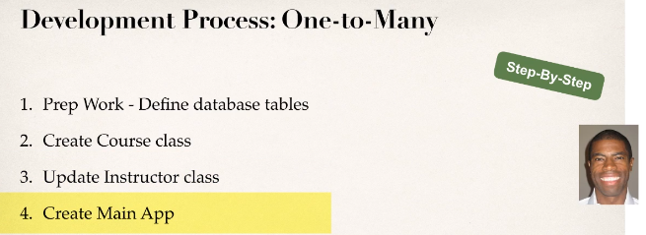
2. **Same as in the previous lecture**.